**Week10-Week12 Assignment**

**Objective:**

Implementing a microservice using the Python Flask framework on an Ubuntu virtual

machine to serve a machine learning prediction model.

To create a Docker image containing everything needed to run the application: the

application code, libraries, tools, dependencies, and other files and to use the image to run the application in containers.

**Steps performed:**

1. Host a Ubuntu Virtual Machine using Oracle VM Virtual Box.

* Downloaded the ISO (Uncompressed Disk Image File format) from the link [ubuntu.com](https://ubuntu.com/download/desktop/thank-you?version=22.04.1&architecture=amd64)

Installation steps followed for Windows:

* Downloaded the setup file of Virtual Box 7.0 from the given link: [Oracle VM VirtualBox](https://www.virtualbox.org/)
* Ran the file and completed the initial setup of the software

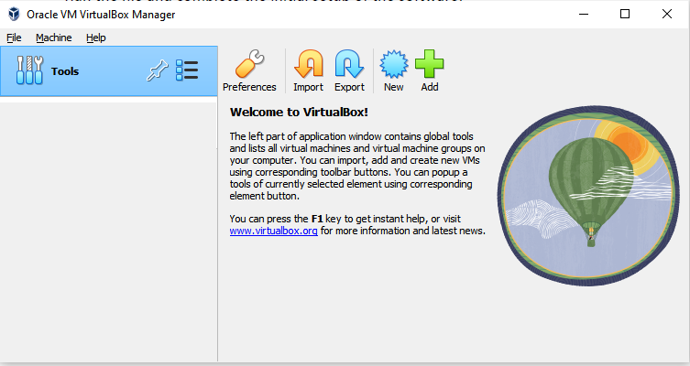

* After Installation, open the Virtual Box.
* Under VM VirtualBox Manager, click on New where OS is named as UbuntuNew .
* Let the folder which is prefilled be left as it is and then select the path of the Ubuntu-22.04.1 iso image where it is located on your laptop/desktop.

(Path displayed in below screenshot)

* Click on next

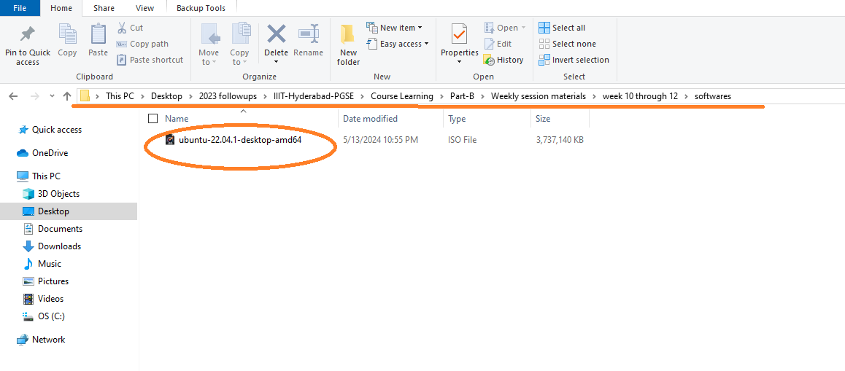

* A screen comes up for Unattended Guest OS installation setup, keep a note of this username and password and click continue, No changes are made here.
* Selected the desired memory size as per requirement.

Memory size selected is 3749 MB

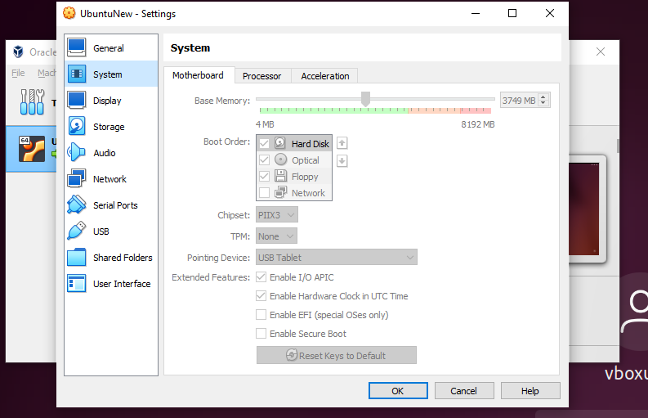

Selected Processor as 1 CPU.

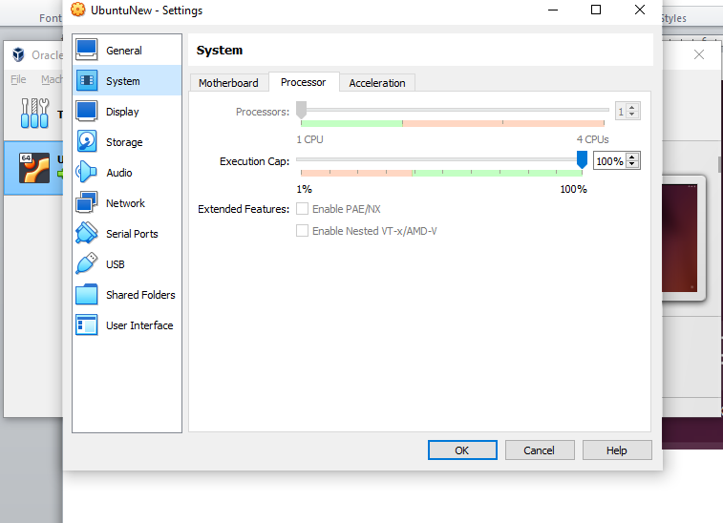

* Selected **Create a Virtual Hard Disk** **Now** option from **the Virtual hard disk window** and **updated the Disk size to 35 GB** allowing more disk space as required and click next .
* Click Finish from the window once Done.
* This finishes the configuration of the Virtual Machine.

**Final Output:**

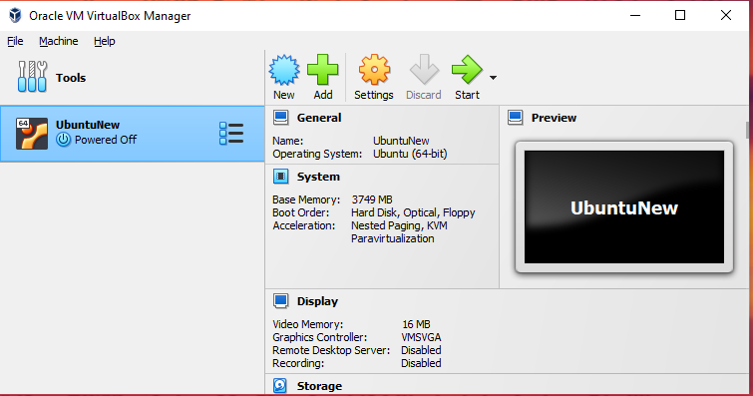

**Part II :**

* Now click on the VM created and click on Settings Advanced to change “Shared Clipboard” and

“Drag ‘n’ Drop” to Bi-Directional as in the below screenshot

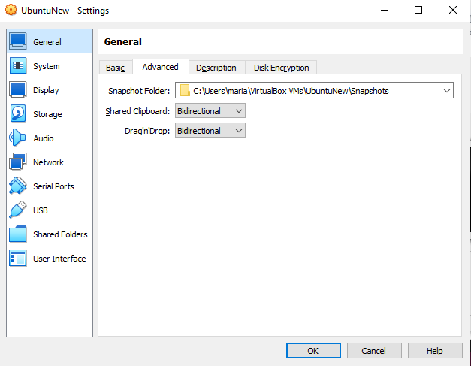

* Now go to Storage and click on Controller IDE.
* Now click on the CD icon in the Attribute section and select the location of the downloaded .iso file.
* Now click OK.

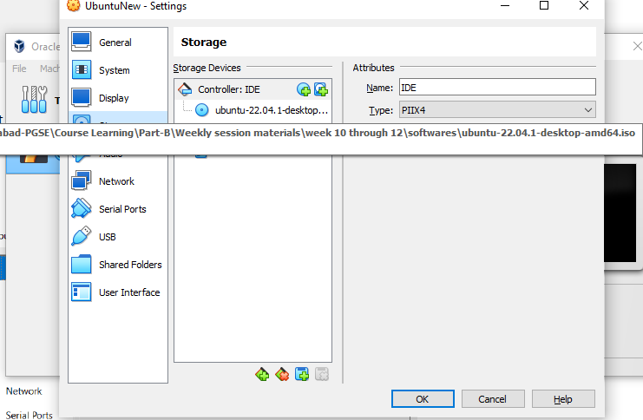

* Now click on the VM Name (UbuntuNew in this case) and click on Start
* Once we click on start interface appears as in the below screenshot

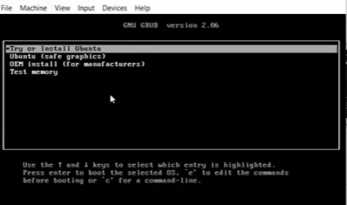

* Now press Enter to begin the installation
* And click on Install Ubuntu and click on continue.
* Provide the required initial setup options like language /keyboard layout and click on continue.
* Similarly, add the location and click continue to input the user similar to the below screenshot, with the username and password of your choice. And, click on “Continue”

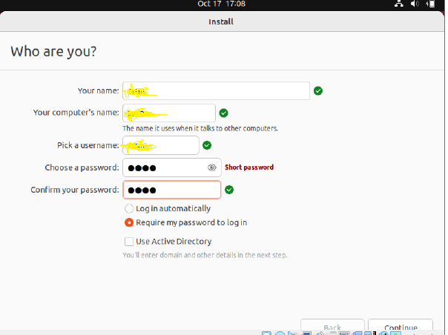

* Wait until the installation is completed and then click on Restart Now to restart the VM and then press **Enter**.

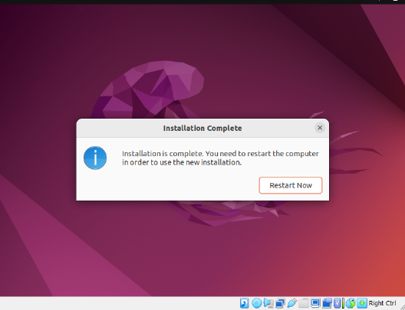

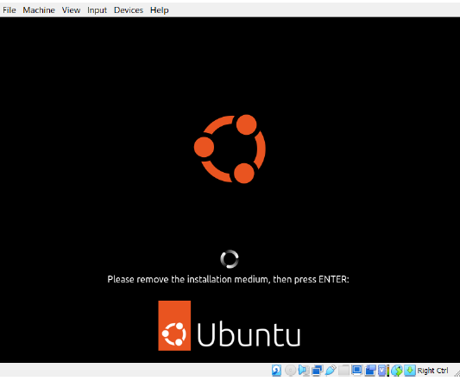

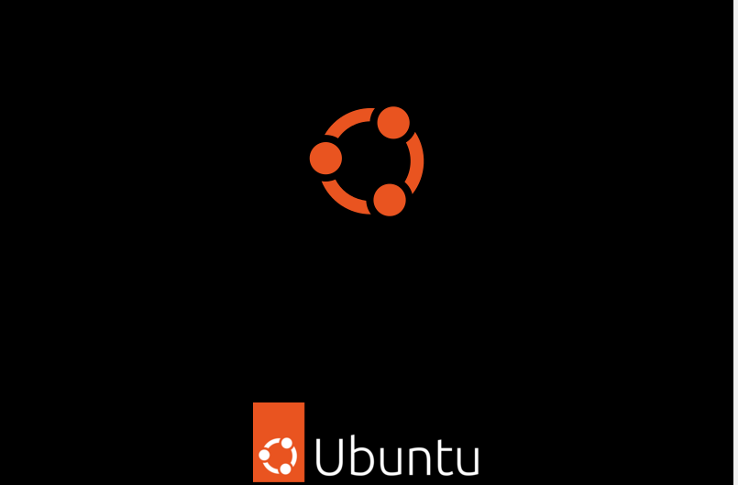

* Now click on the user visible which is the same as the user created earlier and input your credentials.

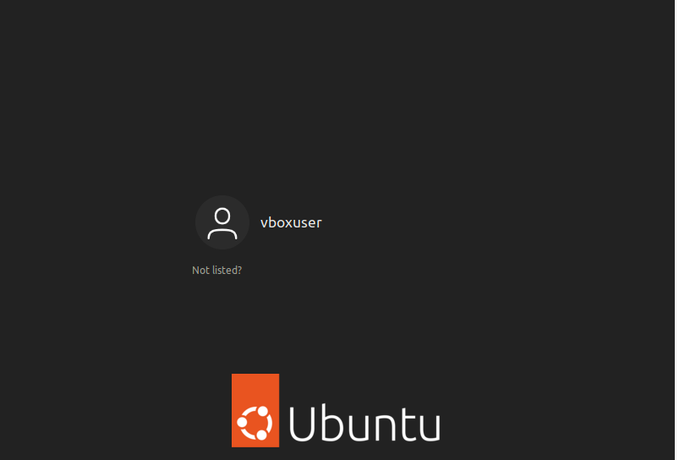

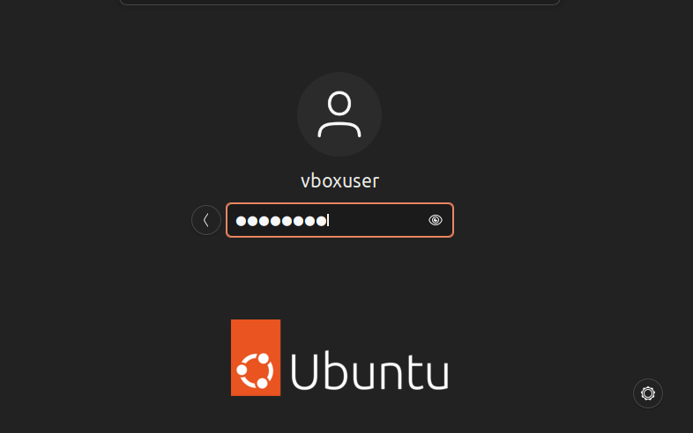

Oracle VM VirtualBox Manager appears as below

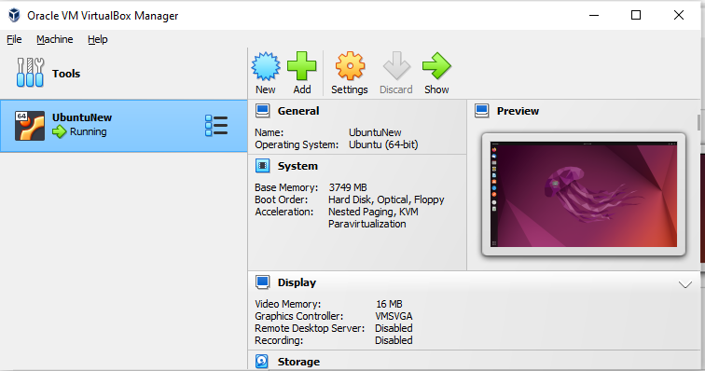

UbuntuNew VirtualBox appears as below . (Activities displayed below)

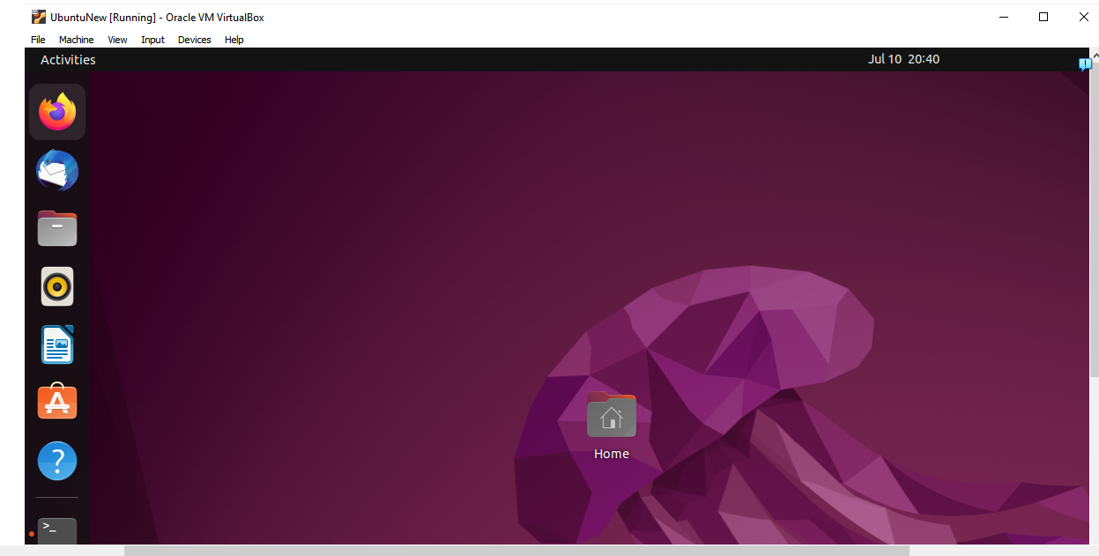

Applications inside a Virtual Box

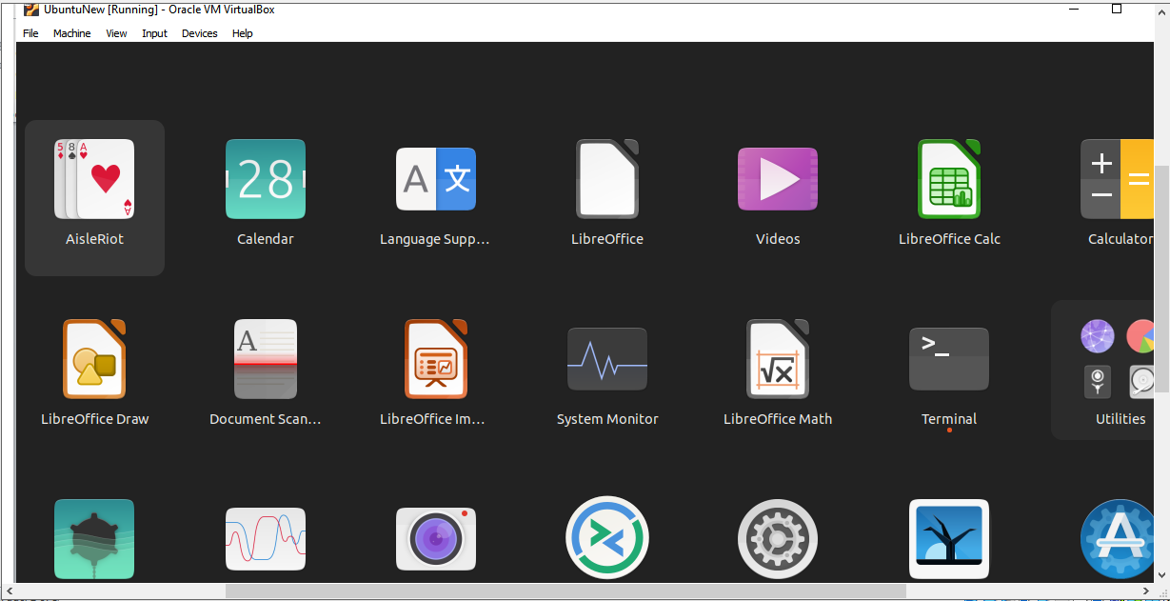

1. Set up Visual Studio code on Ubuntu VM.

Go to the firefox browser on Ubuntu VM and type <https://code.visualstudio.com>. Below screen appears. Download .deb file.

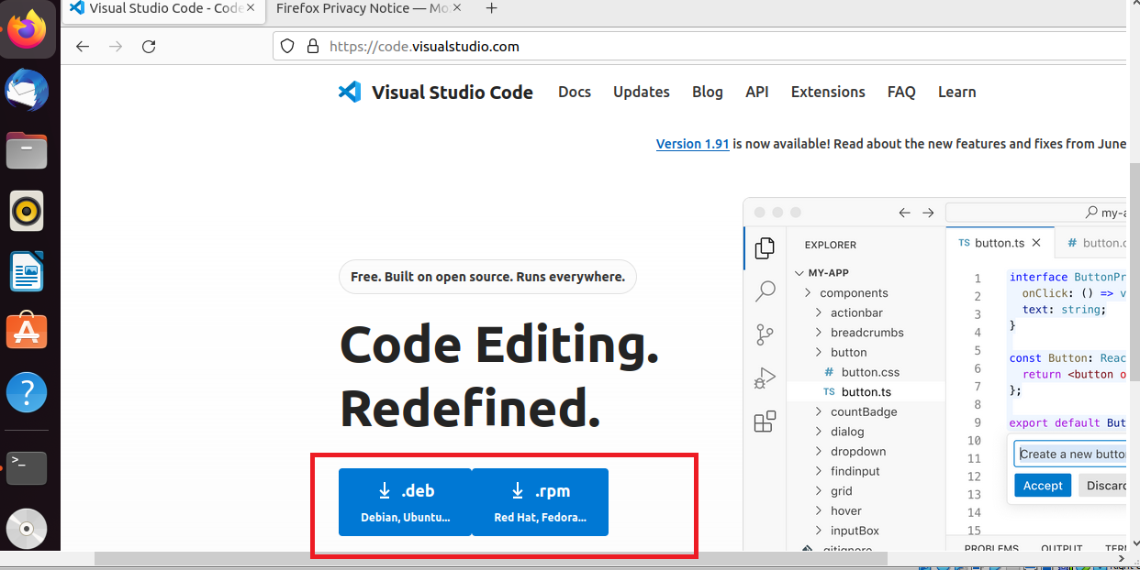

Check the downloaded file under Downloads folder as shown below.

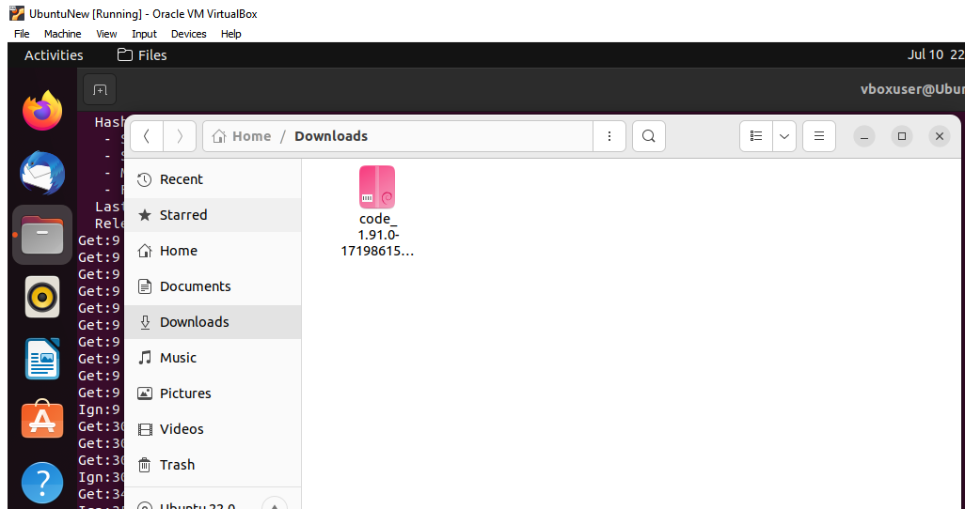

Commands used in terminal:

$ cd Downloads/ - To navigate to the downloads folder

$ ls – To list the files present under downloads

$ sudo dpkg –i xxxxx.deb (xxx here refers to visual studio code deb package name)

Provide the required password.

Below screen is seen which shows unpacking the visual studio code and setting up on the system.

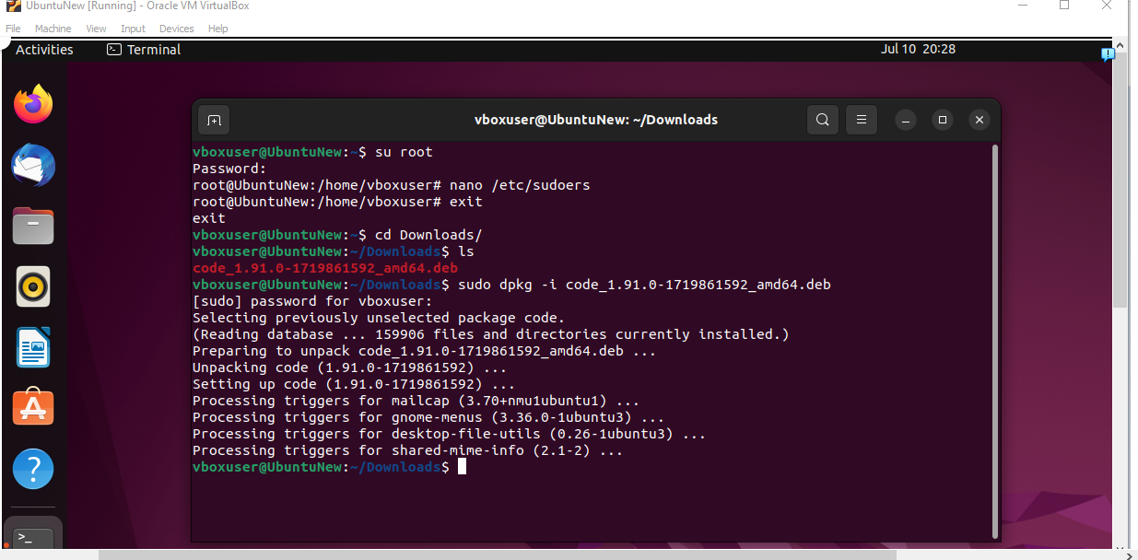

After the above commands are run. We verify for the visual studio code installed successfully.

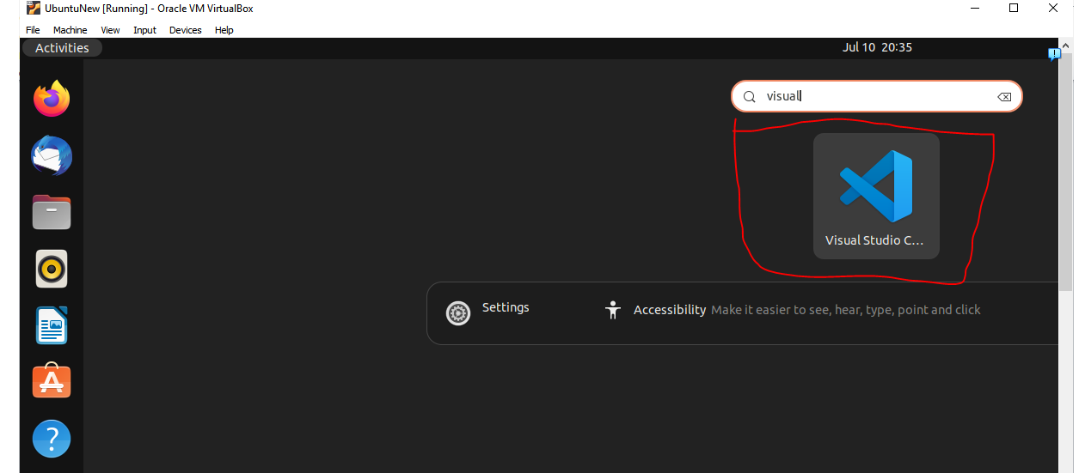

1. Set up Python using below commands

sudo apt update

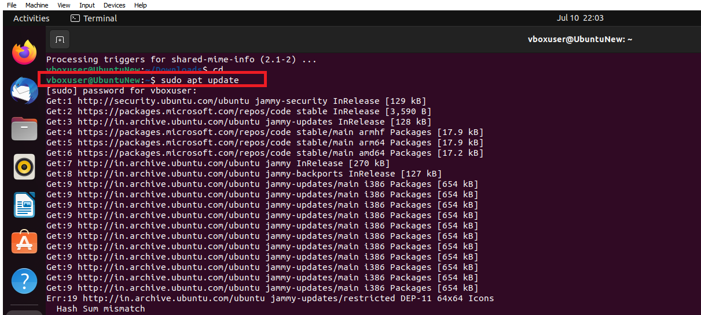

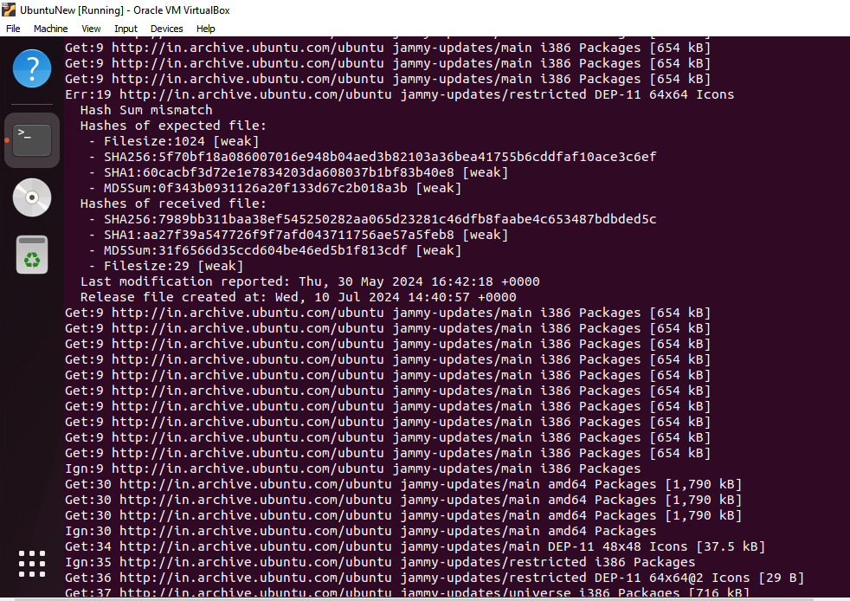

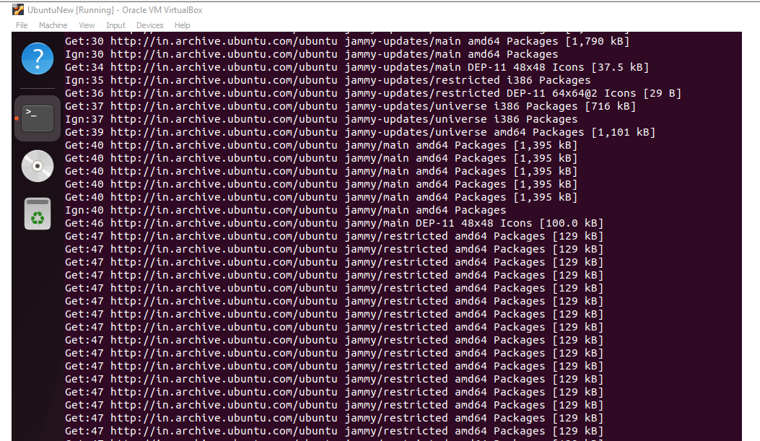

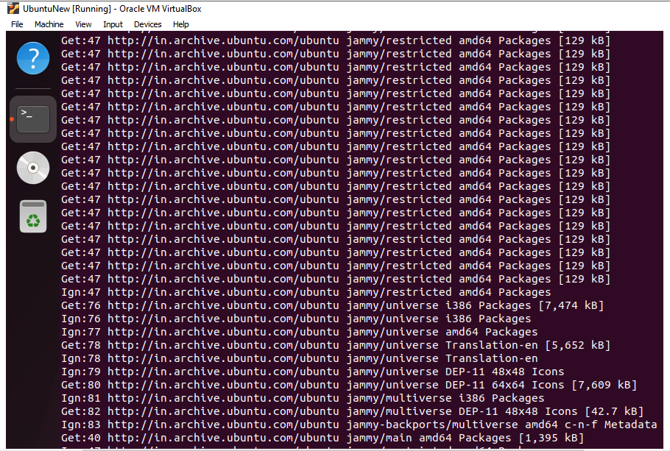

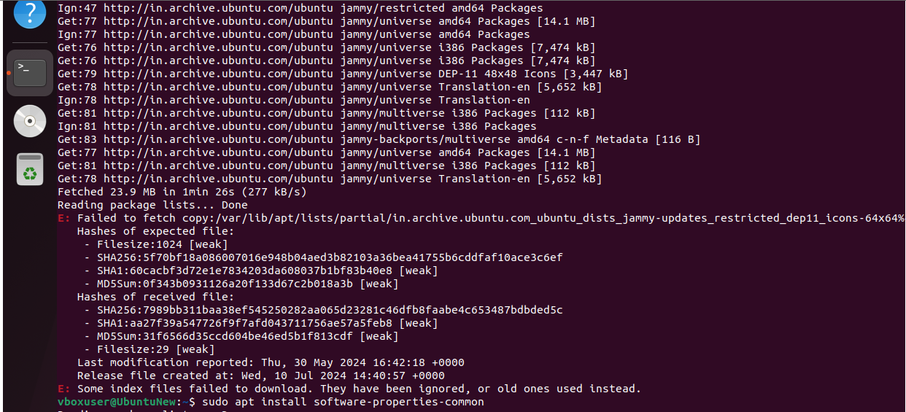

sudo apt install software-properties-common

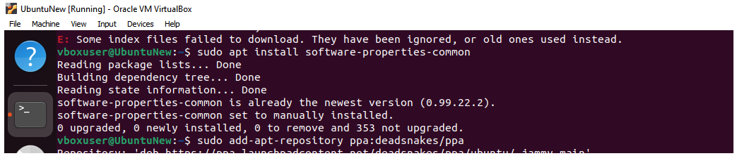

sudo add-apt-repository ppa:deadsnakes/ppa

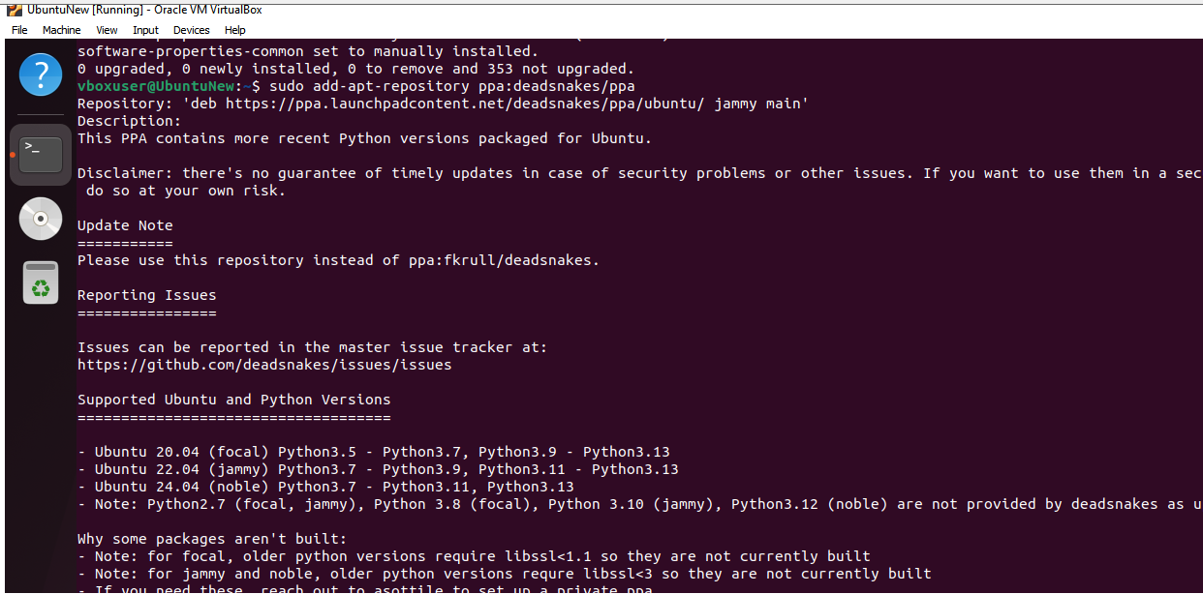

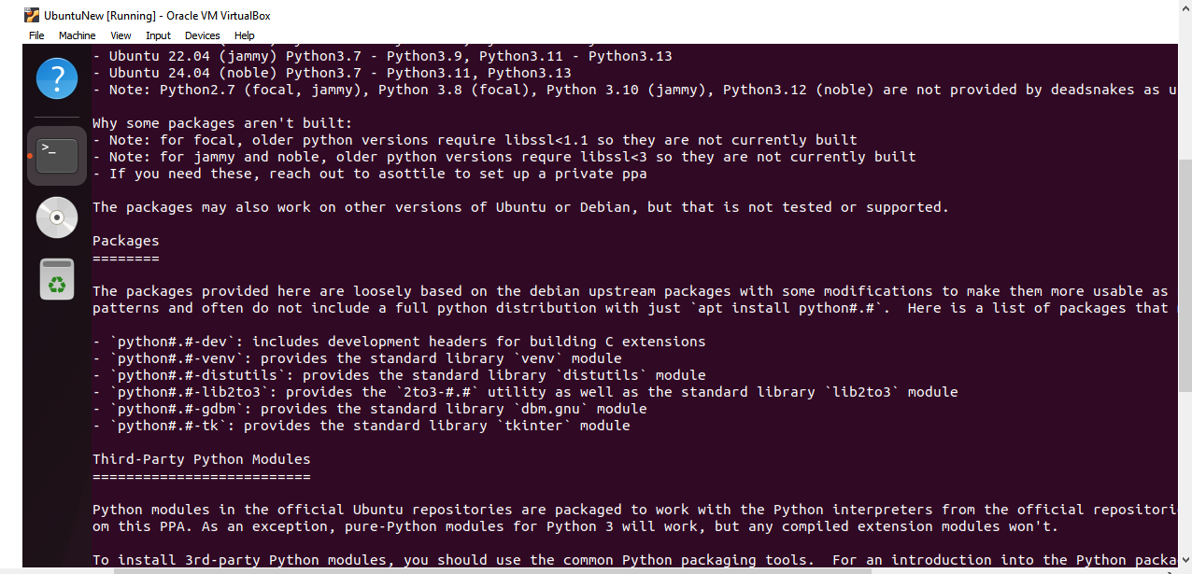

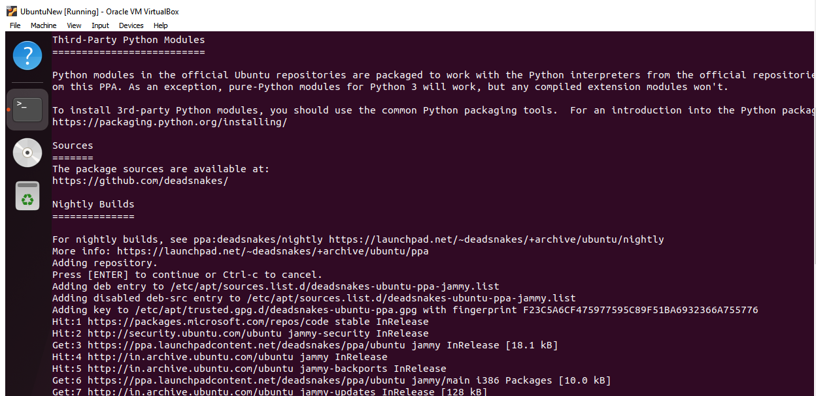

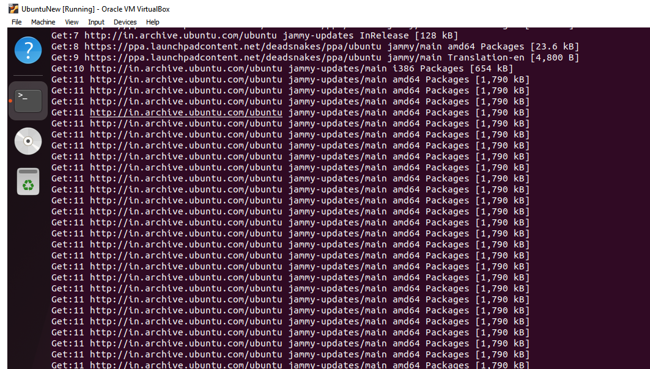

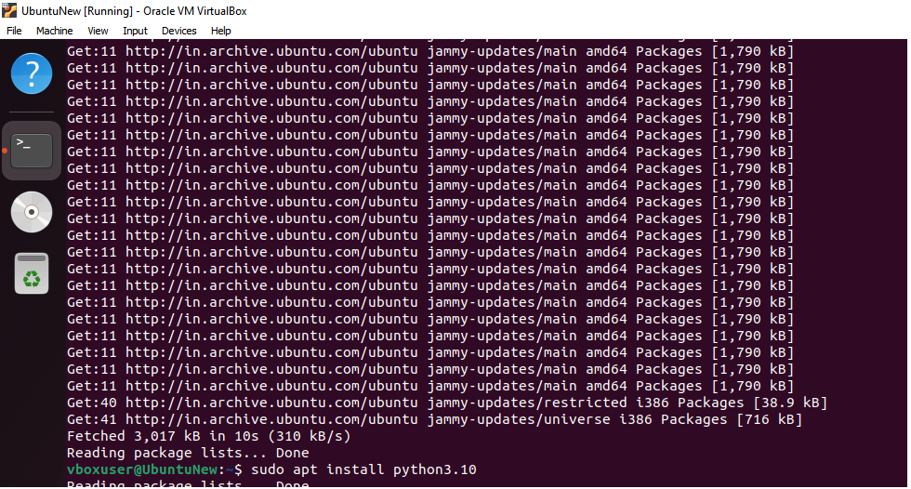

sudo apt install python3.10

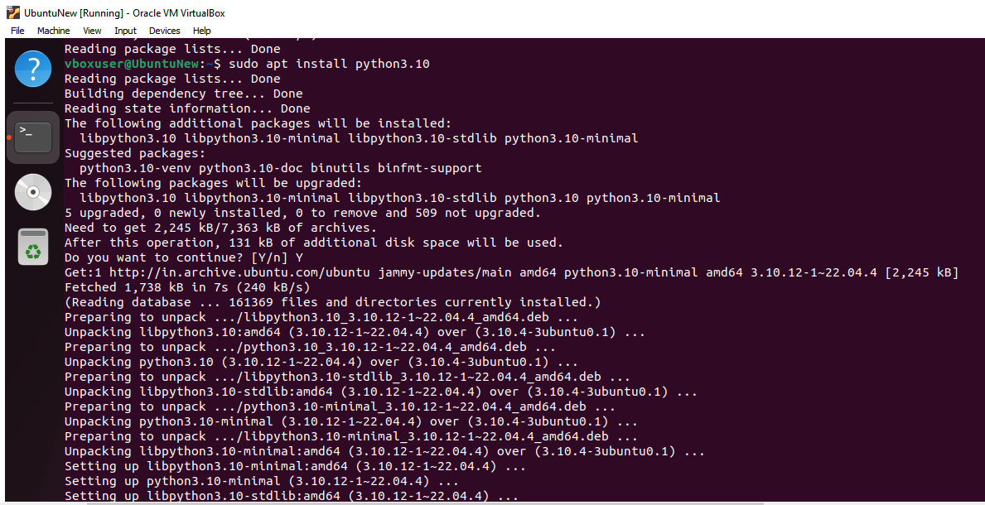

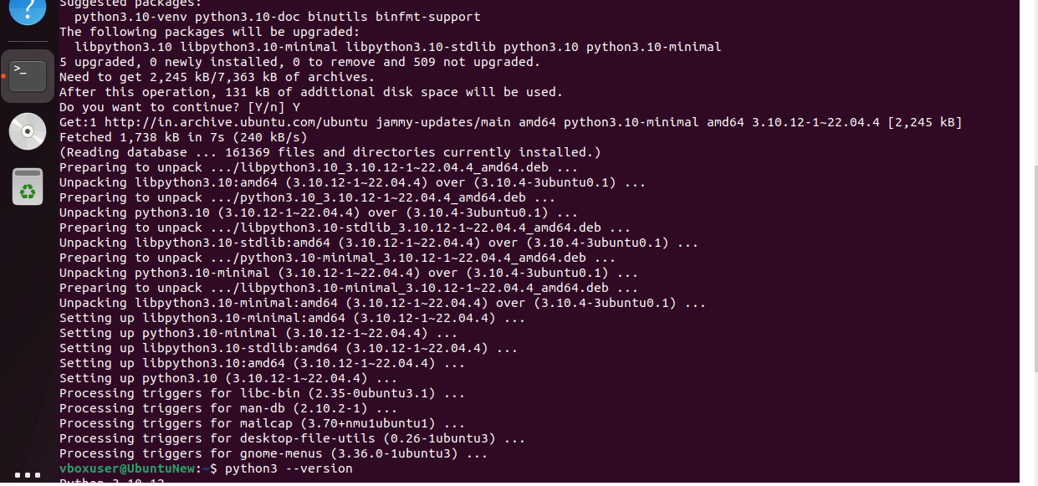

Verification of the installation was successful. Python3 –version

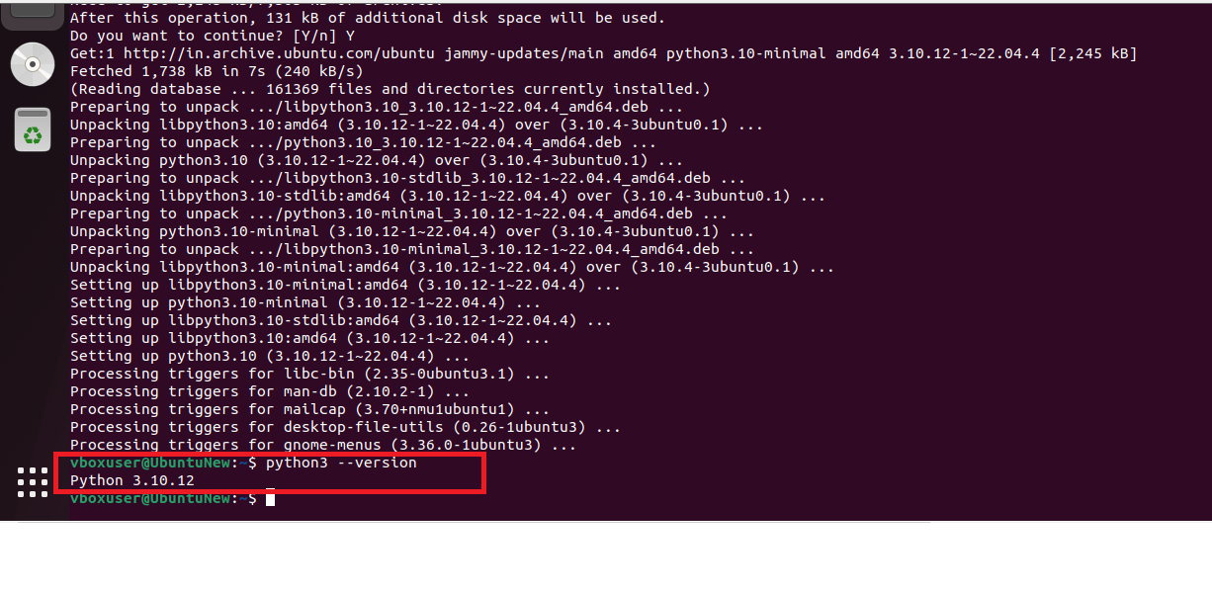

1. Clone this Github repository <https://github.com/Vikas098766/Microservices.git>

Command : git clone https://github.com/Vikas098766/Microservices.git



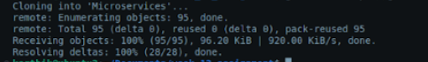

Alternative steps that can be followed to save git folder in VM documents are as below:

In the Oracle VM Virtual box in Ubuntu browser give the url -<https://github.com/Vikas098766/Microservices.git>

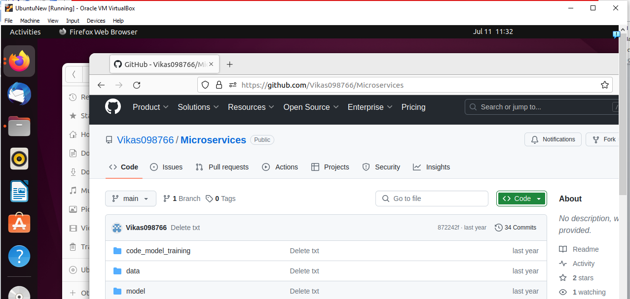

Download the zipped file as highlighted below.

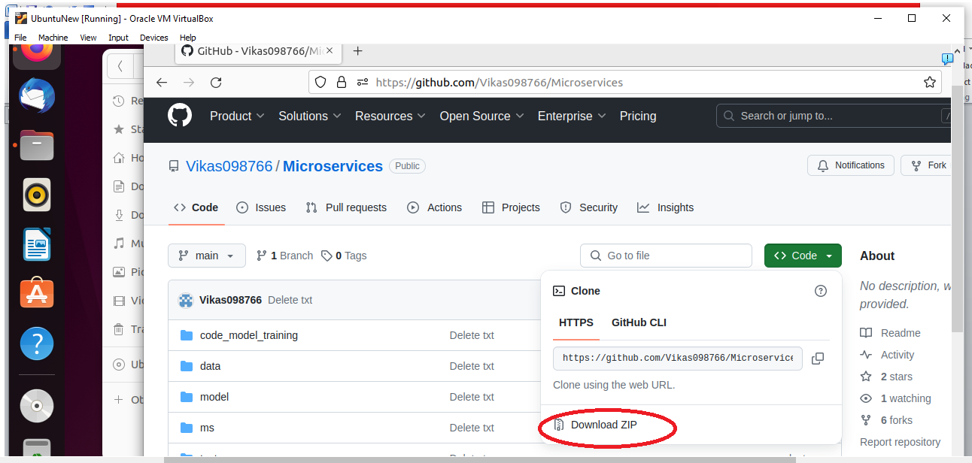

Create a new folder in the Ubuntu VM under Documents as shown below and save the downloaded file here.

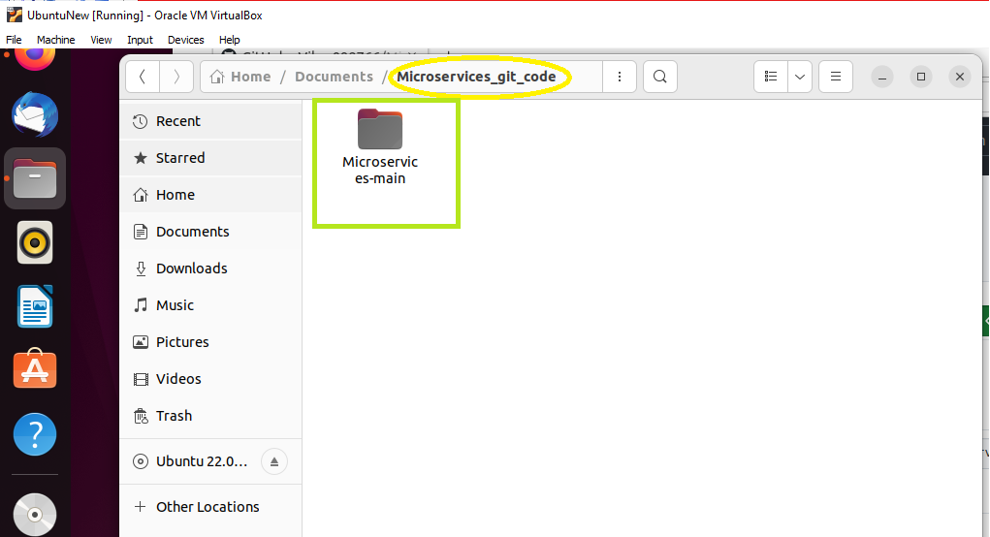

Using the terminal inside the Ubuntu VM ,navigate to this newly created document path

$ cd Documents

$ ls (lists the files created under Documents folder)

$ cd xxxx (xxx refers to new folder name)

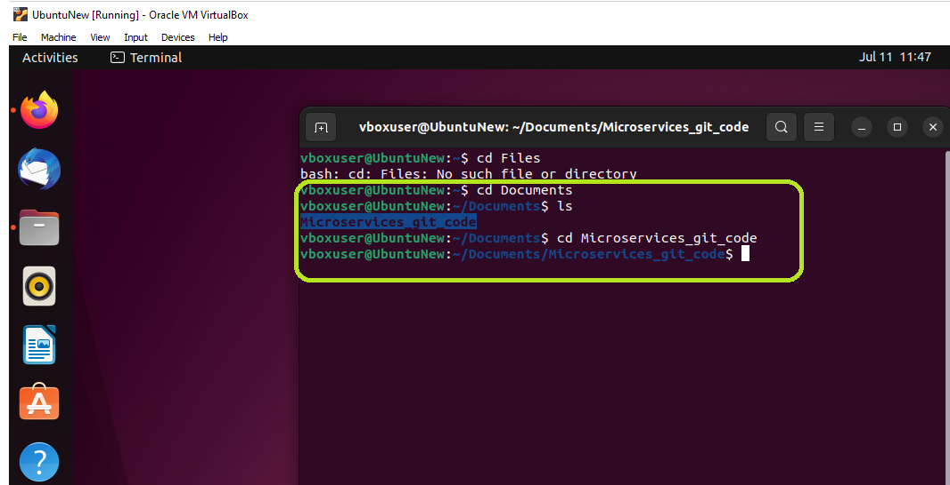

Give the command $code . (code with a space and a dot)

This command launches the visual studio code editor. It opens the directory (folder) you are currently in as a workspace in VS Code.

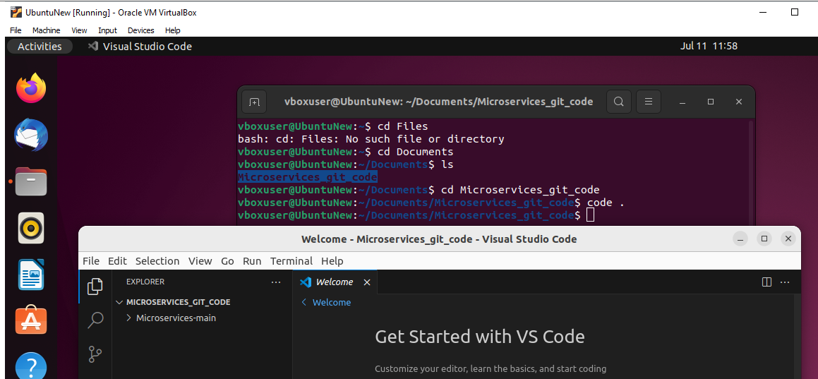

1. Create a Virtual Environment

Command: python3 –m venv venv

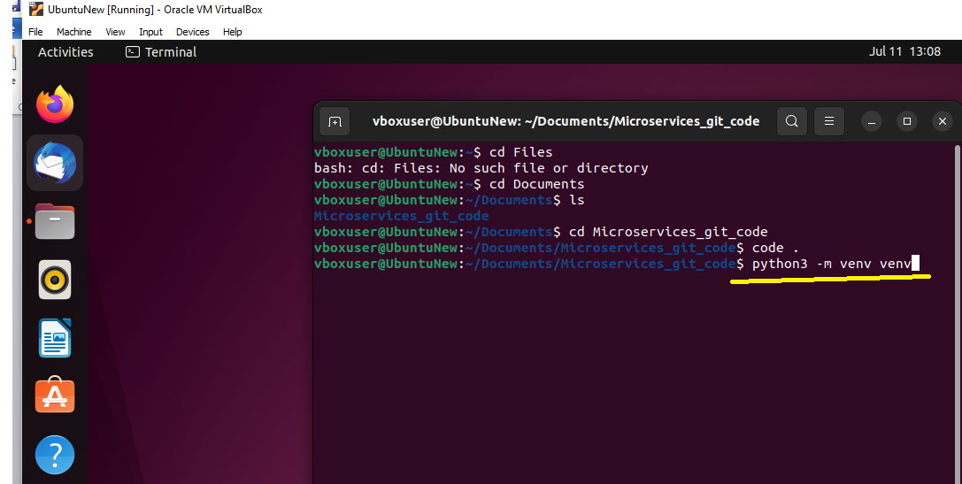

After run:

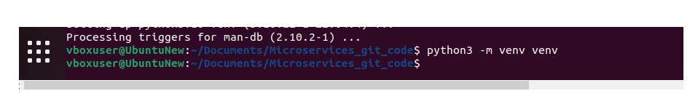

Activate the virtual Environment :

Command: source venv/bin/activate

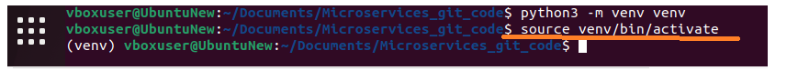

Virtual Environment is created

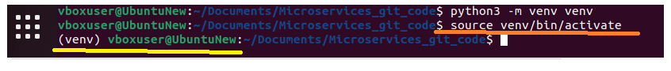

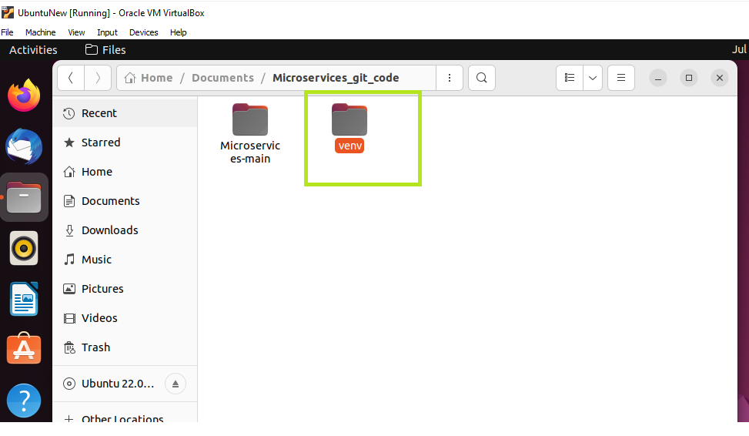

1. Install the dependencies from requirements.txt file.

Command: pip install –r requirements.txt

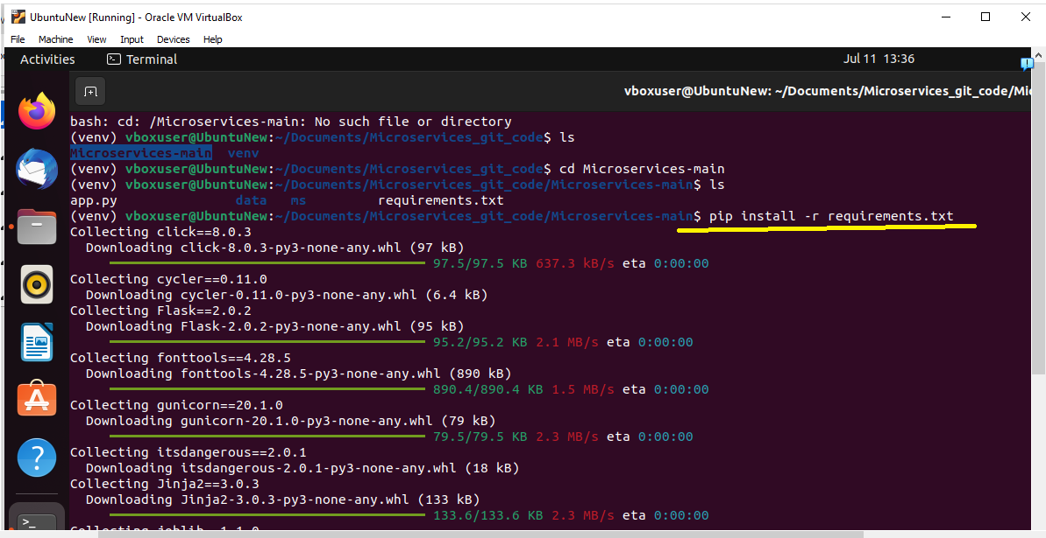

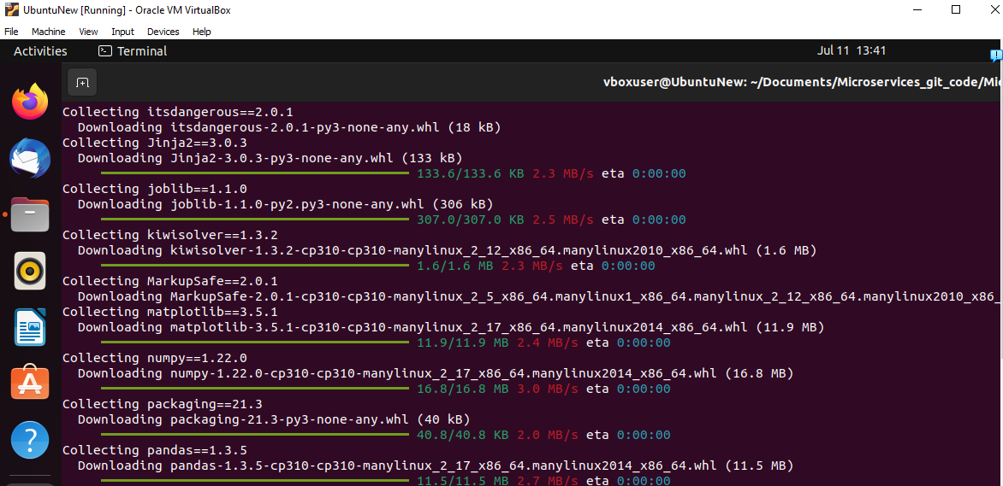

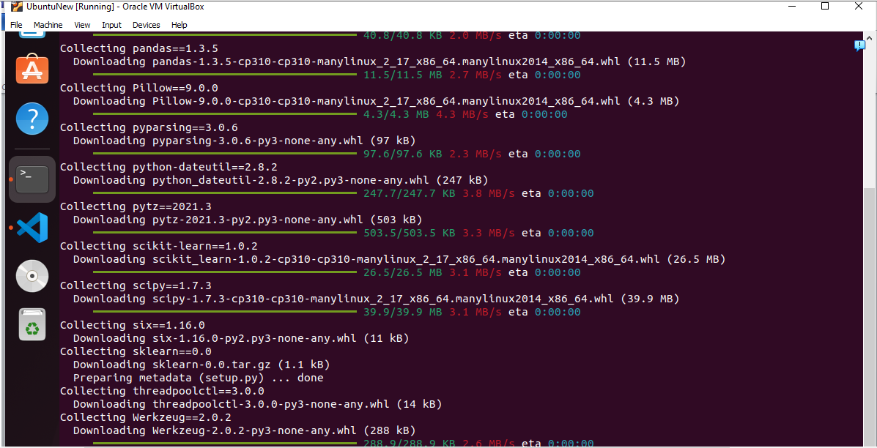

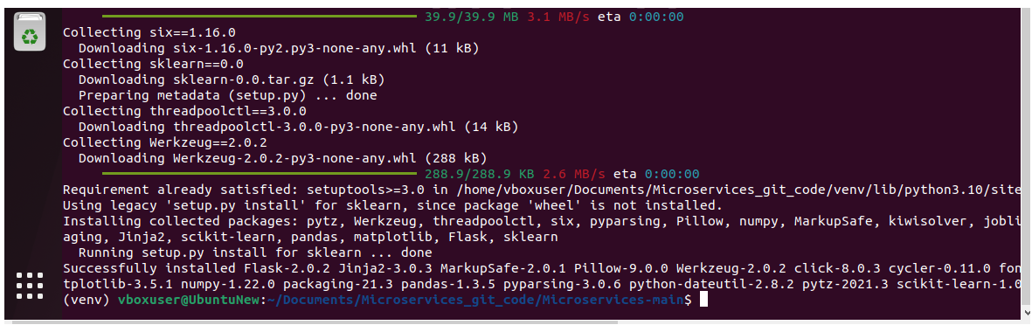

1. Train and save the model

Command : python code_model_training/train.py ( yellow highlighted is the train file located path)

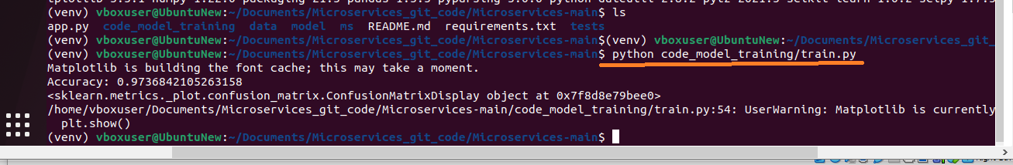

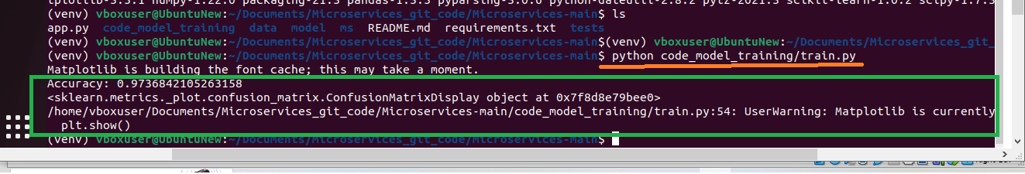

Verify if model is created:

Command: $ls model/

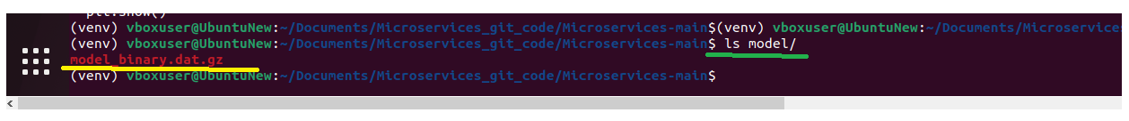

1. Test the Flask web application.

Command : $ flask run –p 5000



After Run:

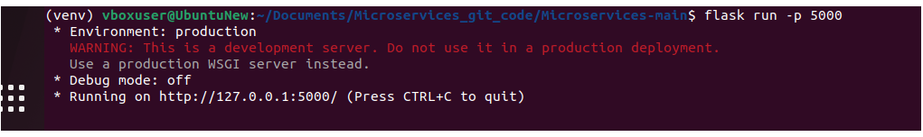

1. Test the application and make predictions using the example calls available in the folder **/tests.**

Command : curl -X GET http://localhost:5000/info

Command : curl -X GET <http://localhost:5000/health>

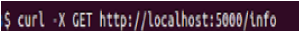



Command : curl -d '[{"radius_mean": 17.99, "texture_mean": 10.38, "perimeter_mean":

122.8, "area_mean": 1001.0, "smoothness_mean": 0.1184, "compactness_mean": 0.2776,

"concavity_mean": 0.3001, "concave points_mean": 0.1471, "symmetry_mean": 0.2419,

"fractal_dimension_mean": 0.07871, "radius_se": 1.095, "texture_se": 0.9053,

"perimeter_se": 8.589, "area_se": 153.4, "smoothness_se": 0.006399, "compactness_se":

0.04904, "concavity_se": 0.05373, "concave points_se": 0.01587, "symmetry_se":

0.03003, "fractal_dimension_se": 0.006193, "radius_worst": 25.38, "texture_worst": 17.33,

"perimeter_worst": 184.6, "area_worst": 2019.0, "smoothness_worst": 0.1622,

"compactness_worst": 0.6656, "concavity_worst": 0.7119, "concave points_worst":

0.2654, "symmetry_worst": 0.4601, "fractal_dimension_worst": 0.1189}]' \ -H

"Content-Type: application/json" \ -X POST <http://0.0.0.0:5000/predict>



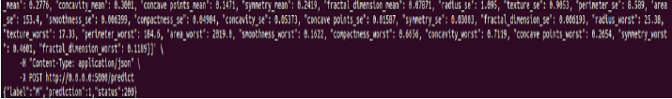

**Verify in the web browser for the GET REST calls-**

Open the firefox browser in the Ubuntu VM and type <http://127.0.0.1:5000/info>

To check info.

Press enter .

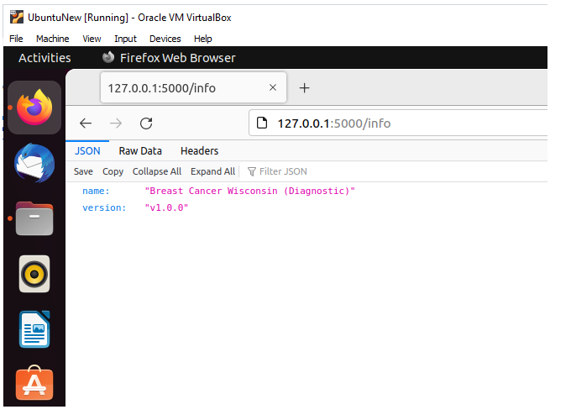

To check the health –type <http://127.0.0.1:5000/health>

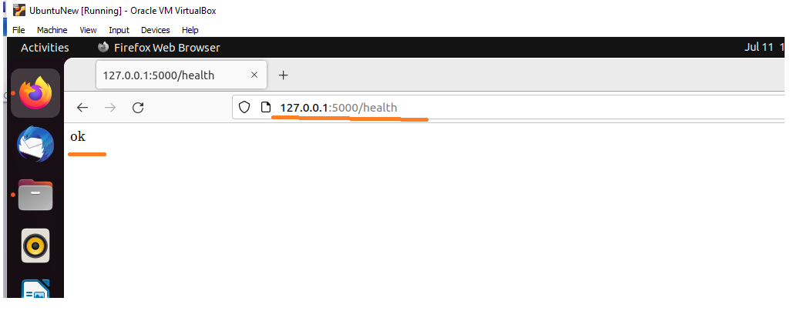

Terminal responses:

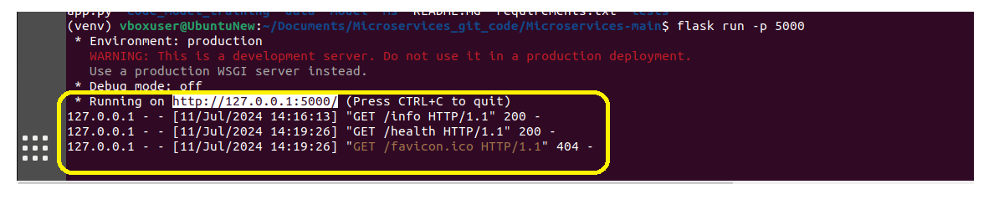

**To run POST rest calls-**

Install addon to the web browser- RESTer

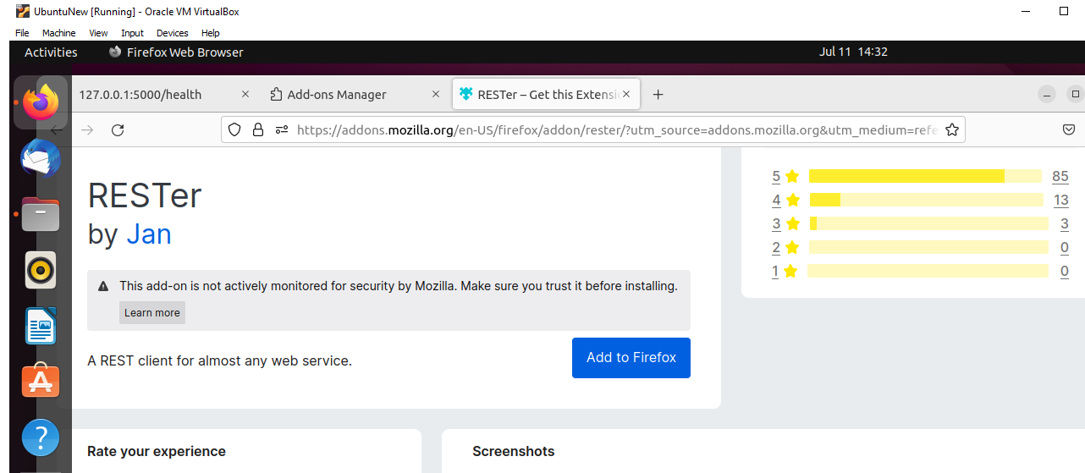

RESTer addon is added and highlighted below to the top right corner.

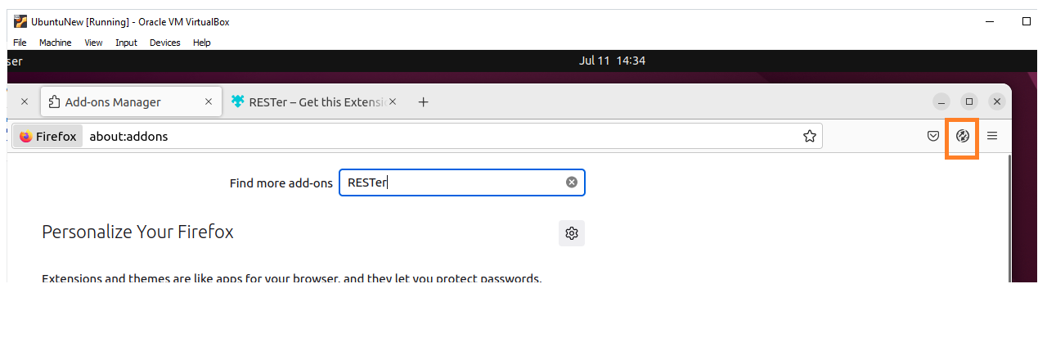

Following window appears on click of the RESTer addon icon.

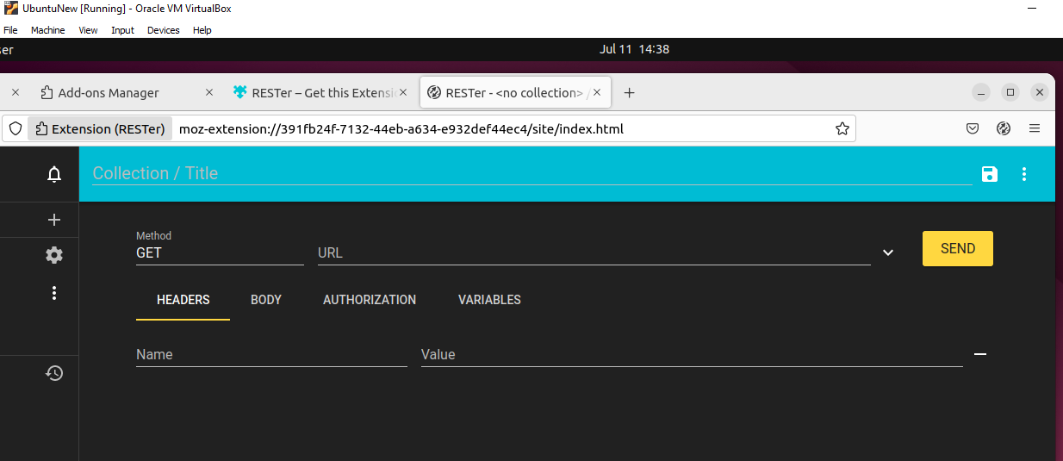

Select the corresponding input and output in each tabs.

Headers tab add and select details as below:

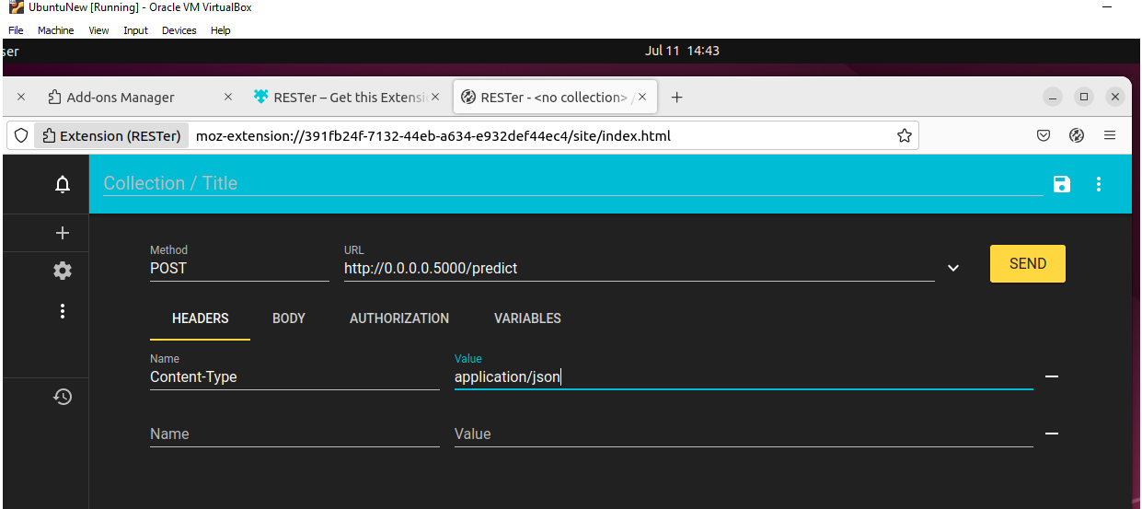

In Body Tab - add the example calls available in the folder **/tests** as seen below

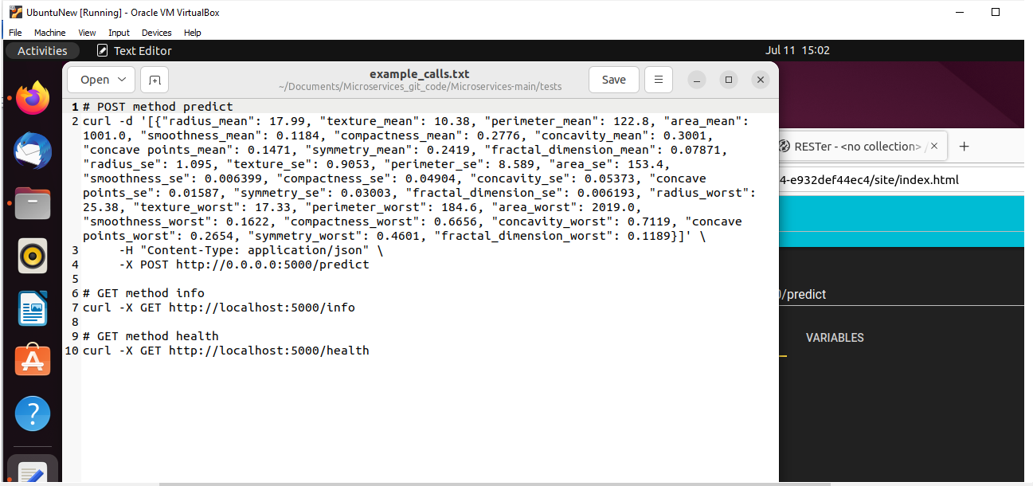

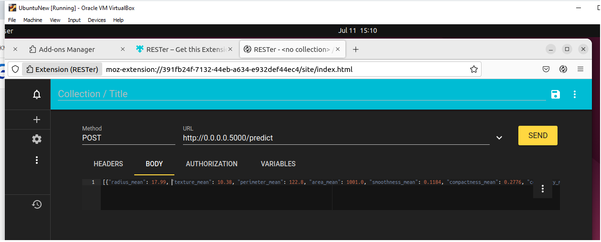

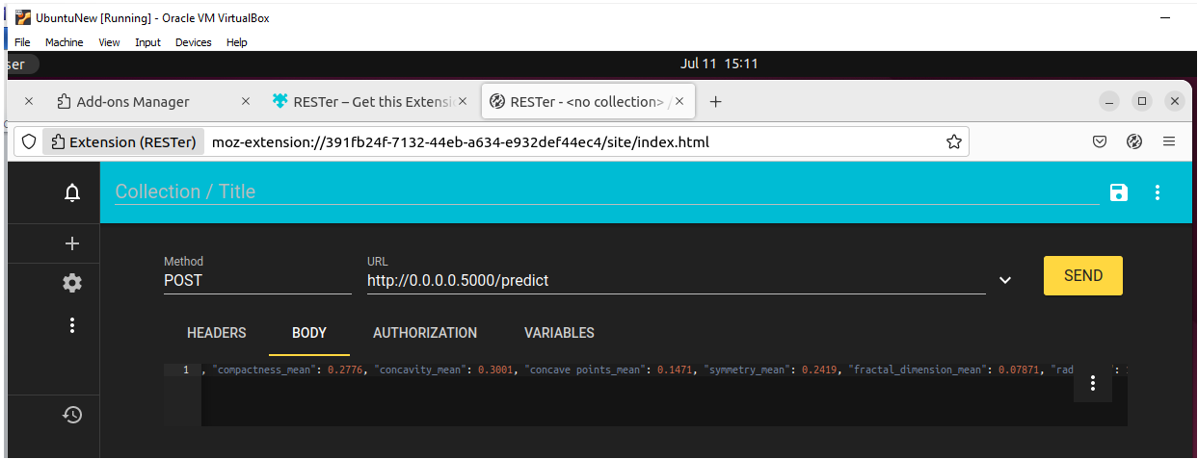

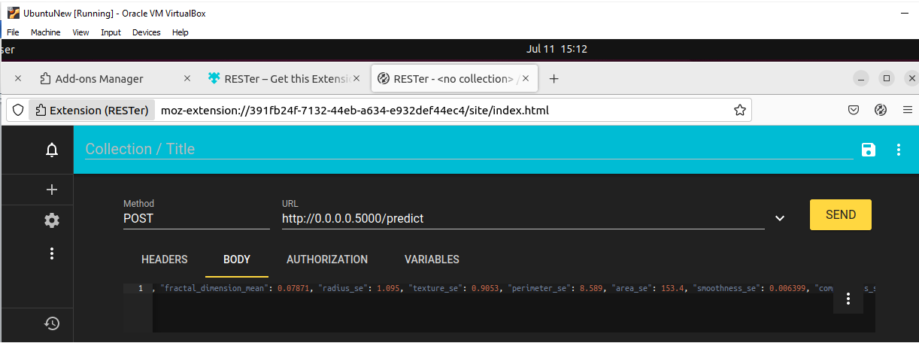

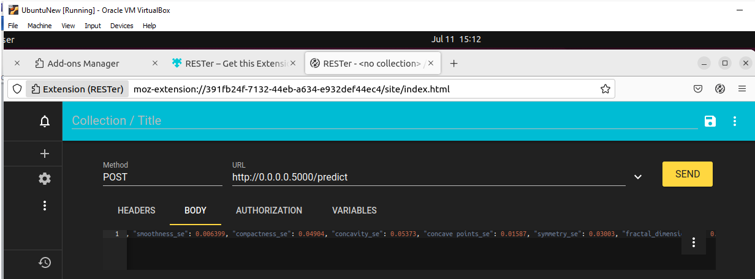

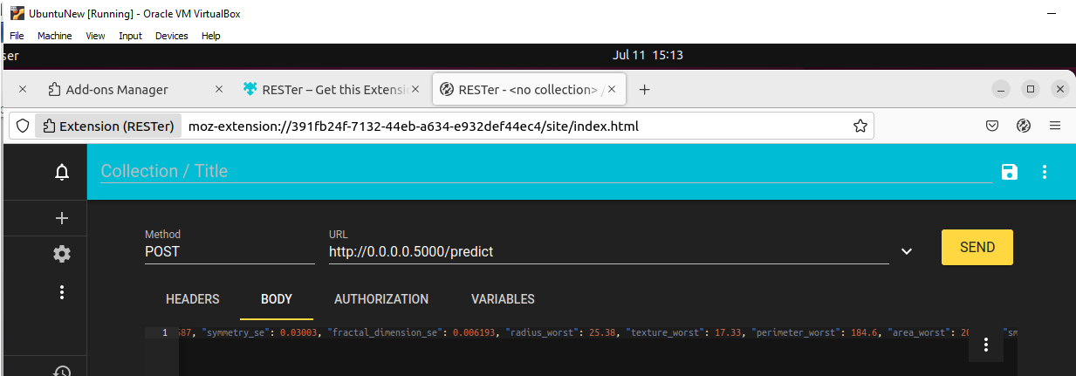

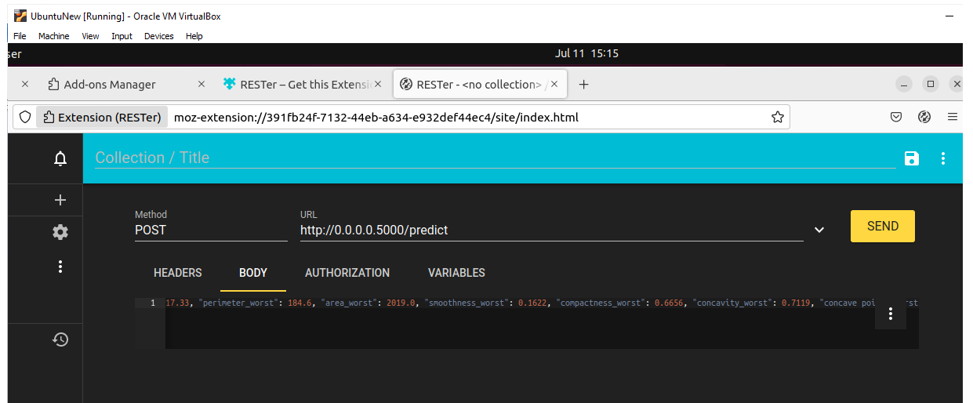

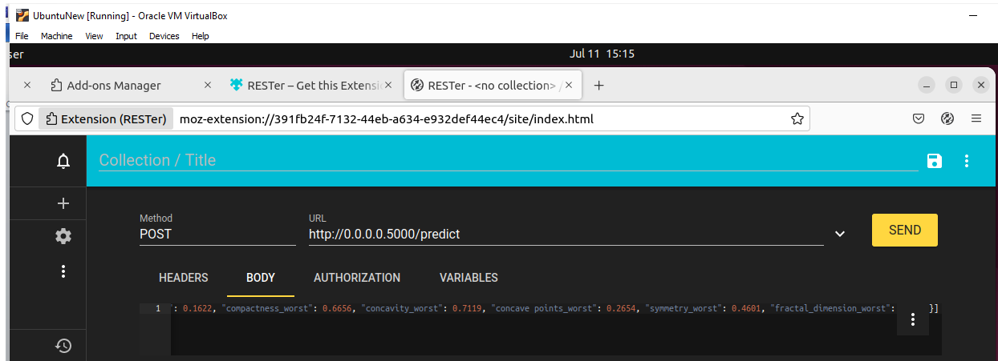

Click on SEND request button on top right. Below Output for Request is seen.

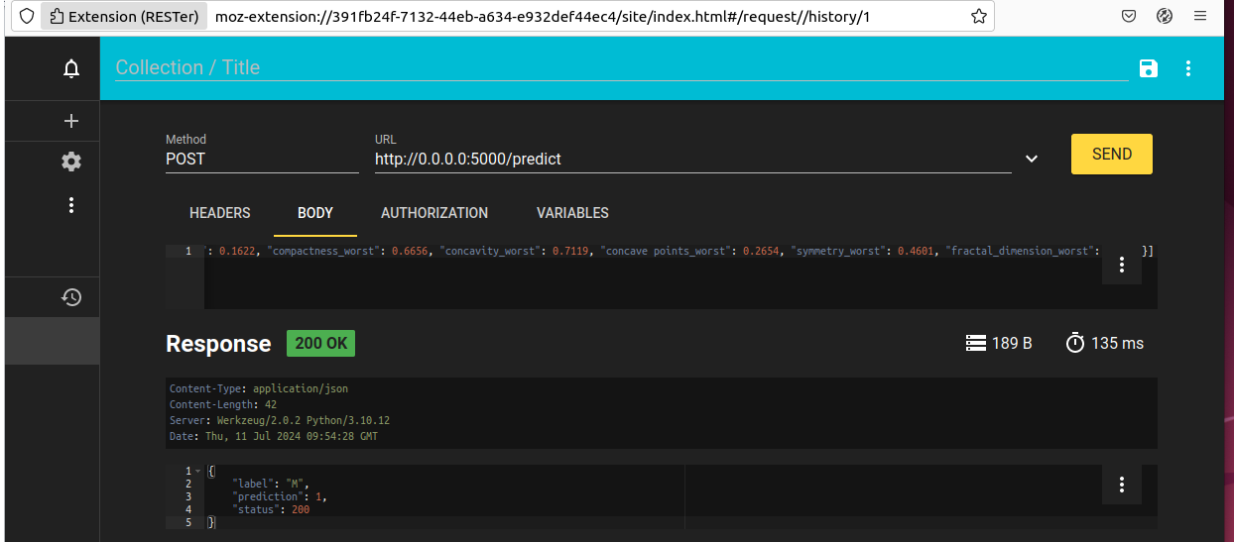

POST rest call displayed in the terminal.

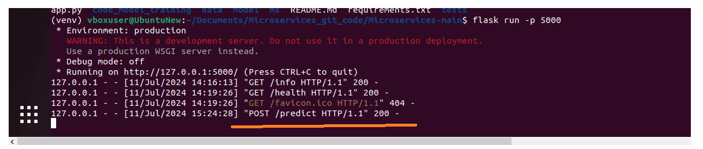

1. Create a docker image containing everything needed to run the application.

Create a new file with command : touch Dockerfile.

This file will contain instructions for building the Docker image.

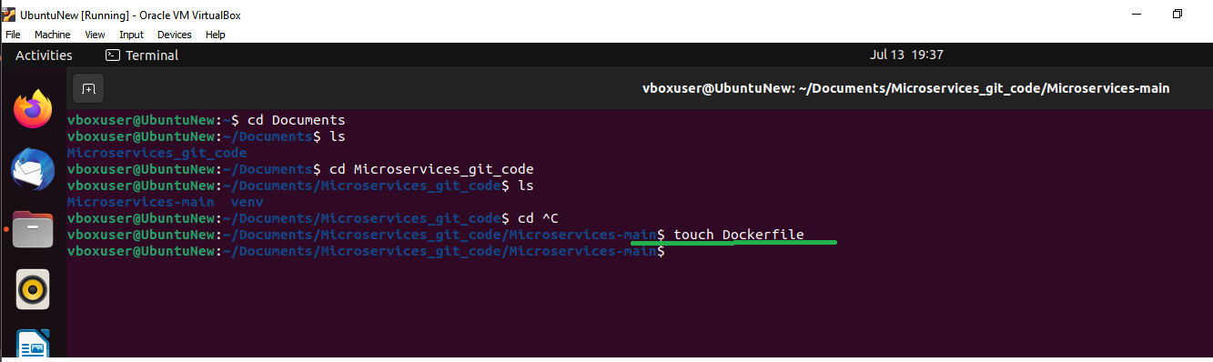

File created

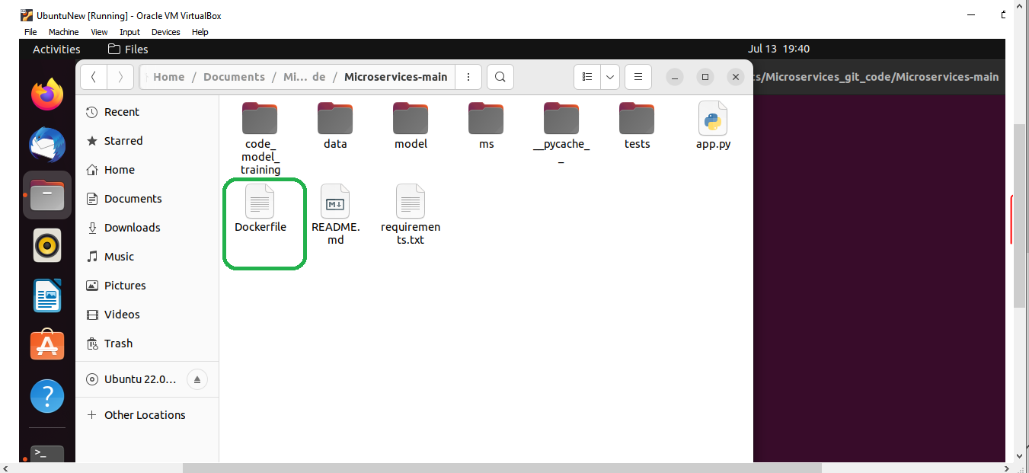

Dockerfile with instructions-

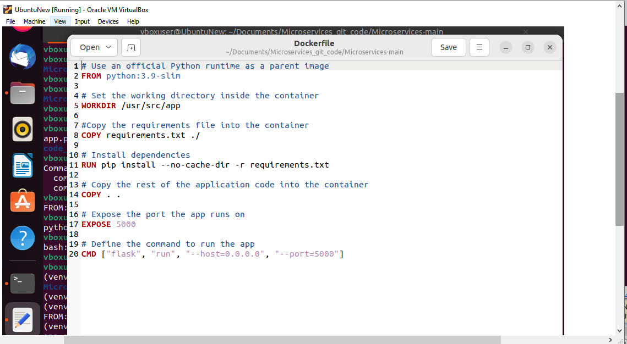

Run the below command in the terminal:

Command: docker build -t my-python-app .

This command reads your Dockerfile and executes the instructions to create an image.

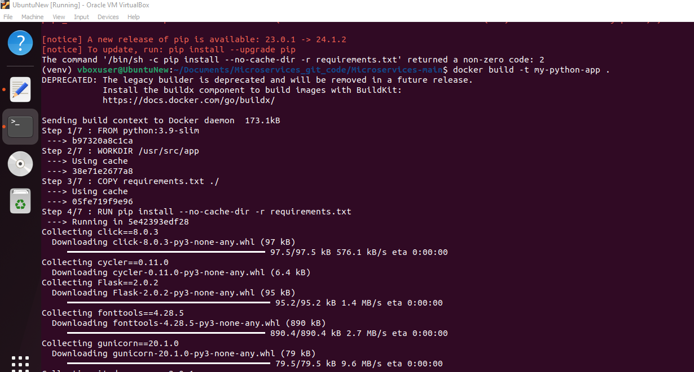

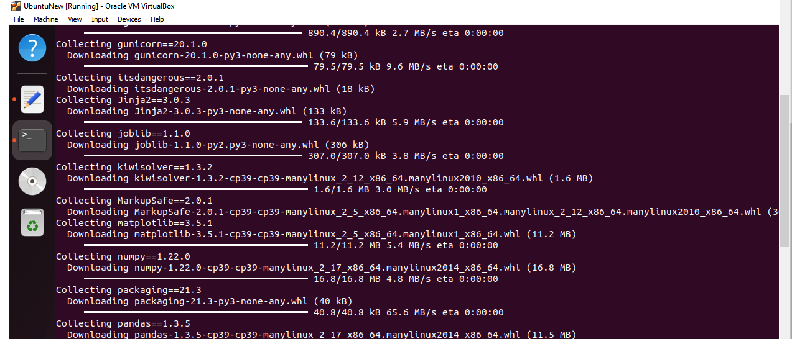

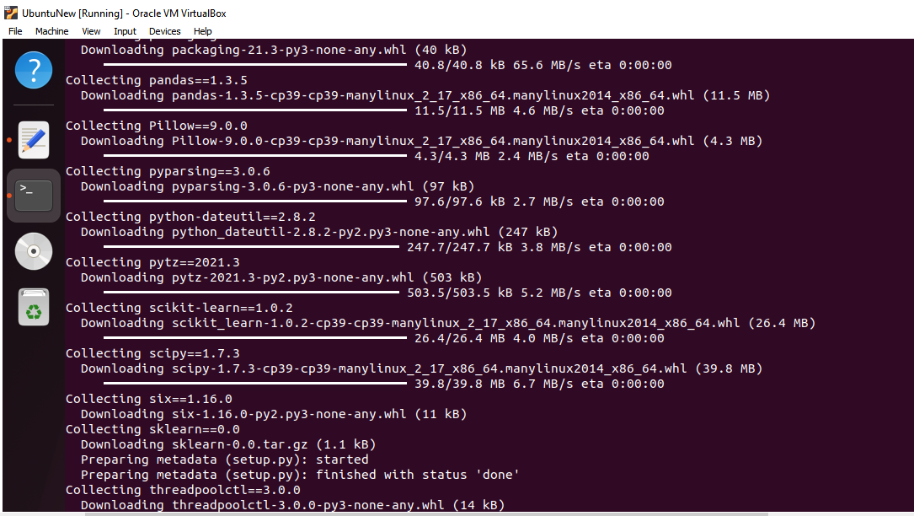

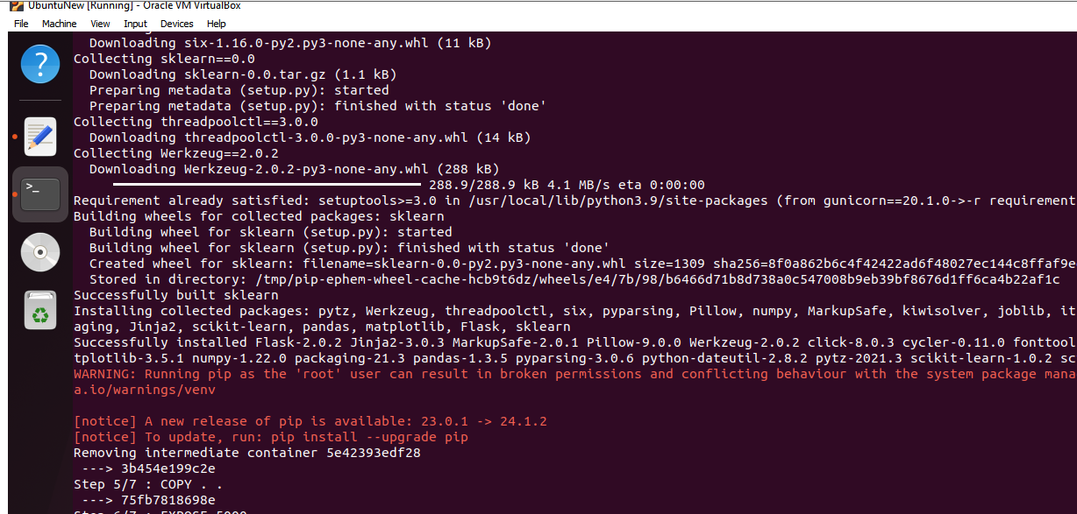

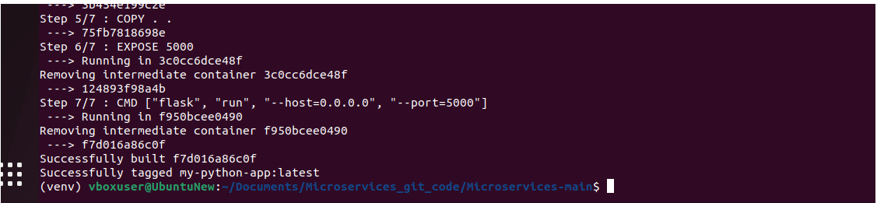

Run docker image as a container-

docker run -p 5000:5000 my-python-app

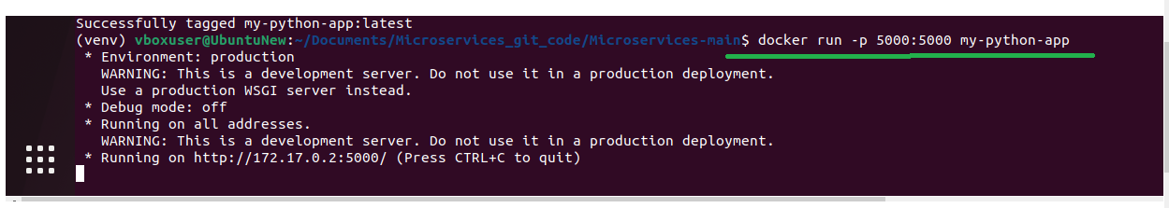

Docker image is running successfully.

11. Run the containerized application as a prediction service and test it locally by passing some example calls and get the prediction.

To check the Docker image service locally :

Verify in the web browser for the GET REST calls-

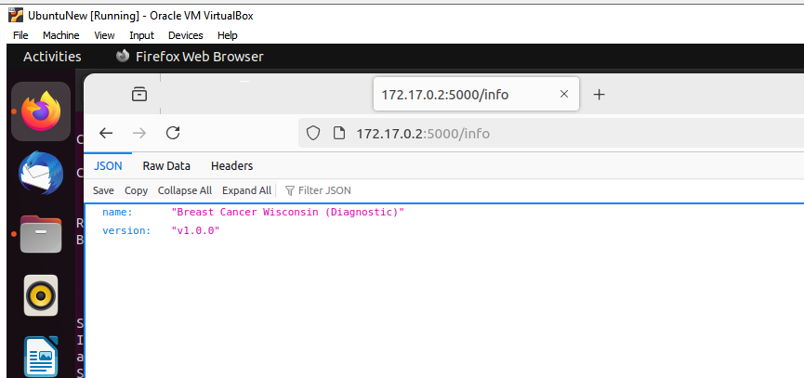

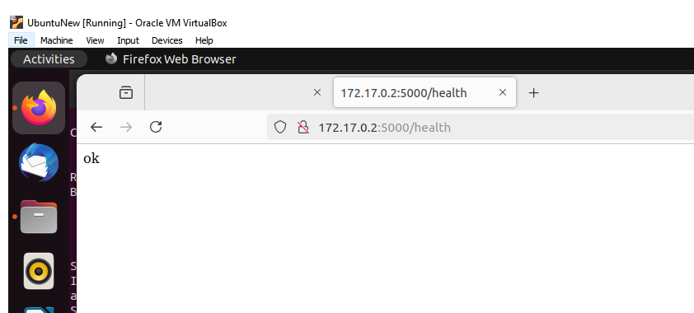

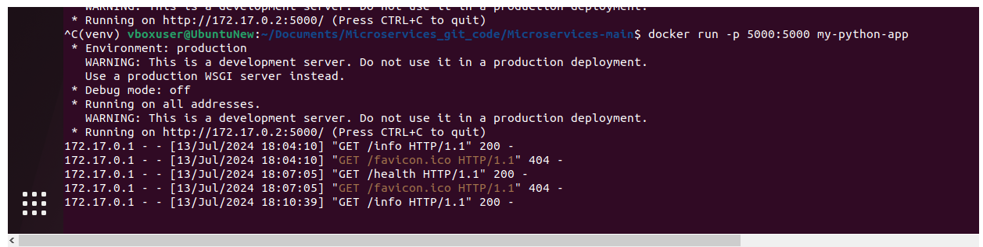

Download Postman from terminal.

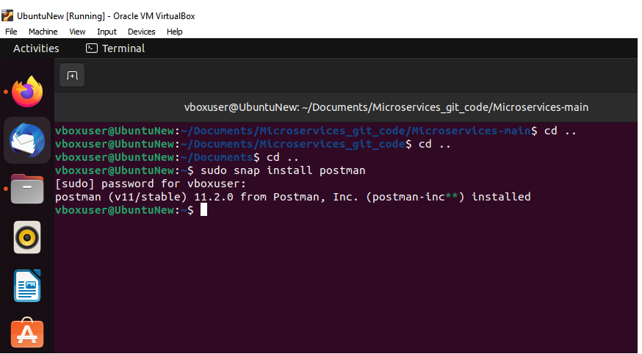

POST Rest calls-

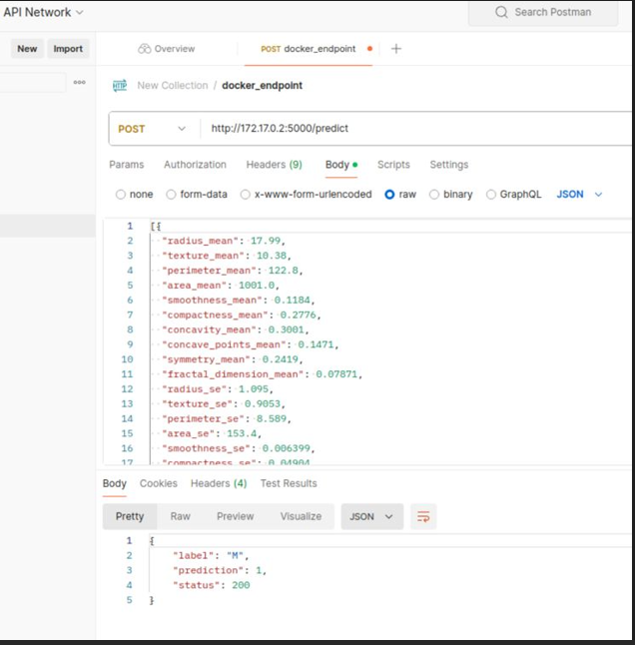

Passed parameters as

[

{

"radius_mean": 17.99,

"texture_mean": 10.38,

"perimeter_mean": 122.8,

"area_mean": 1001.0,

"smoothness_mean": 0.1184,

"compactness_mean": 0.2776,

"concavity_mean": 0.3001,

"concave_points_mean": 0.1471,

"symmetry_mean": 0.2419,

"fractal_dimension_mean": 0.07871,

"radius_se": 1.095,

"texture_se": 0.9053,

"perimeter_se": 8.589,

"area_se": 153.4,

"smoothness_se": 0.006399,

"compactness_se": 0.04904,

"concavity_se": 0.05373,

"concave_points_se": 0.01587,

"symmetry_se": 0.03003,

"fractal_dimension_se": 0.006193,

"radius_worst": 25.38,

"texture_worst": 17.33,

"perimeter_worst": 184.6,

"area_worst": 2019.0,

"smoothness_worst": 0.1622,

"compactness_worst": 0.6656,

"concavity_worst": 0.7119,

"concave_points_worst": 0.2654,

"symmetry_worst": 0.4601,

"fractal_dimension_worst": 0.1189

}

]